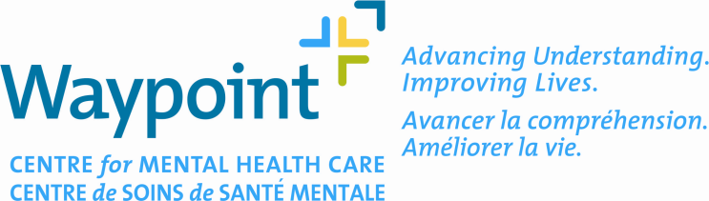

General Checklist for Submission of New Studies
The following relevant items in the general checklist (see next page) must be submitted for review and approval by the Research Ethics Board before initiating a new study at Waypoint. The checklist must accompany the TAHSN Application Form.

It is highly encouraged that an electronic copy of the submission be provided in addition to the submission in paper format.

Has this Research been Approved by Manager, Research & Academics Department and a completed Waypoint Research Application Form (WRAF) Yes No

If, Yes, proceed with your submission to the REB. If, Not, please obtain WRAF approval first, before submitting to the REB.

Date of Application: Name of Principal Investigator (PI):

Does the PI of the study have a primary appointment at Waypoint? Yes No

If No, has a Waypoint PI been appointed for taking responsibility of local supervision?
Yes No

Name of Local Principal Investigator (PI):

Study Title:

*Note: It is the responsibility of PI to verify and adhere to Waypoint’s policies regarding posting posters/flyers/ advertisements on institutional website and notice boards. Compliance in terms of using specific Waypoint brand templates may need to be followed. Please check with the Director, Communications and Fund Raising in the Public Relations Department at 705-549-3181 x2214 or 1-877-341-4729 x2214 for more information. Waypoint’s REB must review the contents of the form and give approval before the final posting.

For Checklist Items, see next page.

Yes | N/A | GENERAL CHECKLIST ITEMS
Cover Letter to include,
- Date, Study Title, PI Name, Type of Study, Type of Review Requesting (Full Board or Delegated Review)
- If No Consent Form then a rational must be provided
 |  | Completed Waypoint Research Application Form (WRAF) approved by Manager, Research and Academics
 |  | Completed and signed Human Subjects Research Application Form (TAHSN) – no references should be made to another document.
 |  | Completed General Checklist included with each copy of the TAHSN Form
 |  | All signatures included with names clearly printed below
 |  | All material collated and double-sided
 |  | Is this an investigator–initiated clinical trial?
 |  | Is the research going to be conducted at Waypoint?
 |  | Does the research involve patients or clients at Waypoint?
 |  | Protocol, most recent version (version date format recommended, yyyy-Mmm-dd)
 |  | Consent Form–Main Study (version date format recommended, yyyy-Mmm-dd)
 |  | Consent Form–Other (version date format recommended, yyyy-Mmm-dd))
 |  | Consent Form Checklist
 |  | Posters/Flyers/Advertisement if recruiting research participants by this method* (see Note above)
 |  | Investigator Brochure (IB)
 |  | Patient Questionnaire(s) – (copies separate from the protocol)
 |  | Patient Diary(ies) – (copies separate from the protocol)
 |  | Patient Materials – Other (copies separate from the protocol)
 |  | Health Canada ‘No-Objection Letter’ (NOL)
 |  | Sponsor’s Study Budget and Grant
 |  | Budget for Internally Funded Studies
 |  | All non-standard instruments to be used in the study
 |  | Curriculum Vita for Principal Investigator and Co-Investigator(s) at Waypoint (N/A if the current version within 1 year is on file with the REB)
 |  | List of everyone involved in a trial or study
 |  | Other (e.g. Prohibited Drug List; Product Monograph; Wallet Card)
 |  | Approval letter from other REBs
 |  | Research Ethics Board Attestation Form (if required)
 |  | For Industry Sponsored Trials a Non-refundable REB Review Fee ($1500) will be issued to the Sponsor. Please indicate the name of the contact person for the Sponsor:
 |  | Certificate (s) of Completion for the Tri-Council Policy Statement Tutorial

